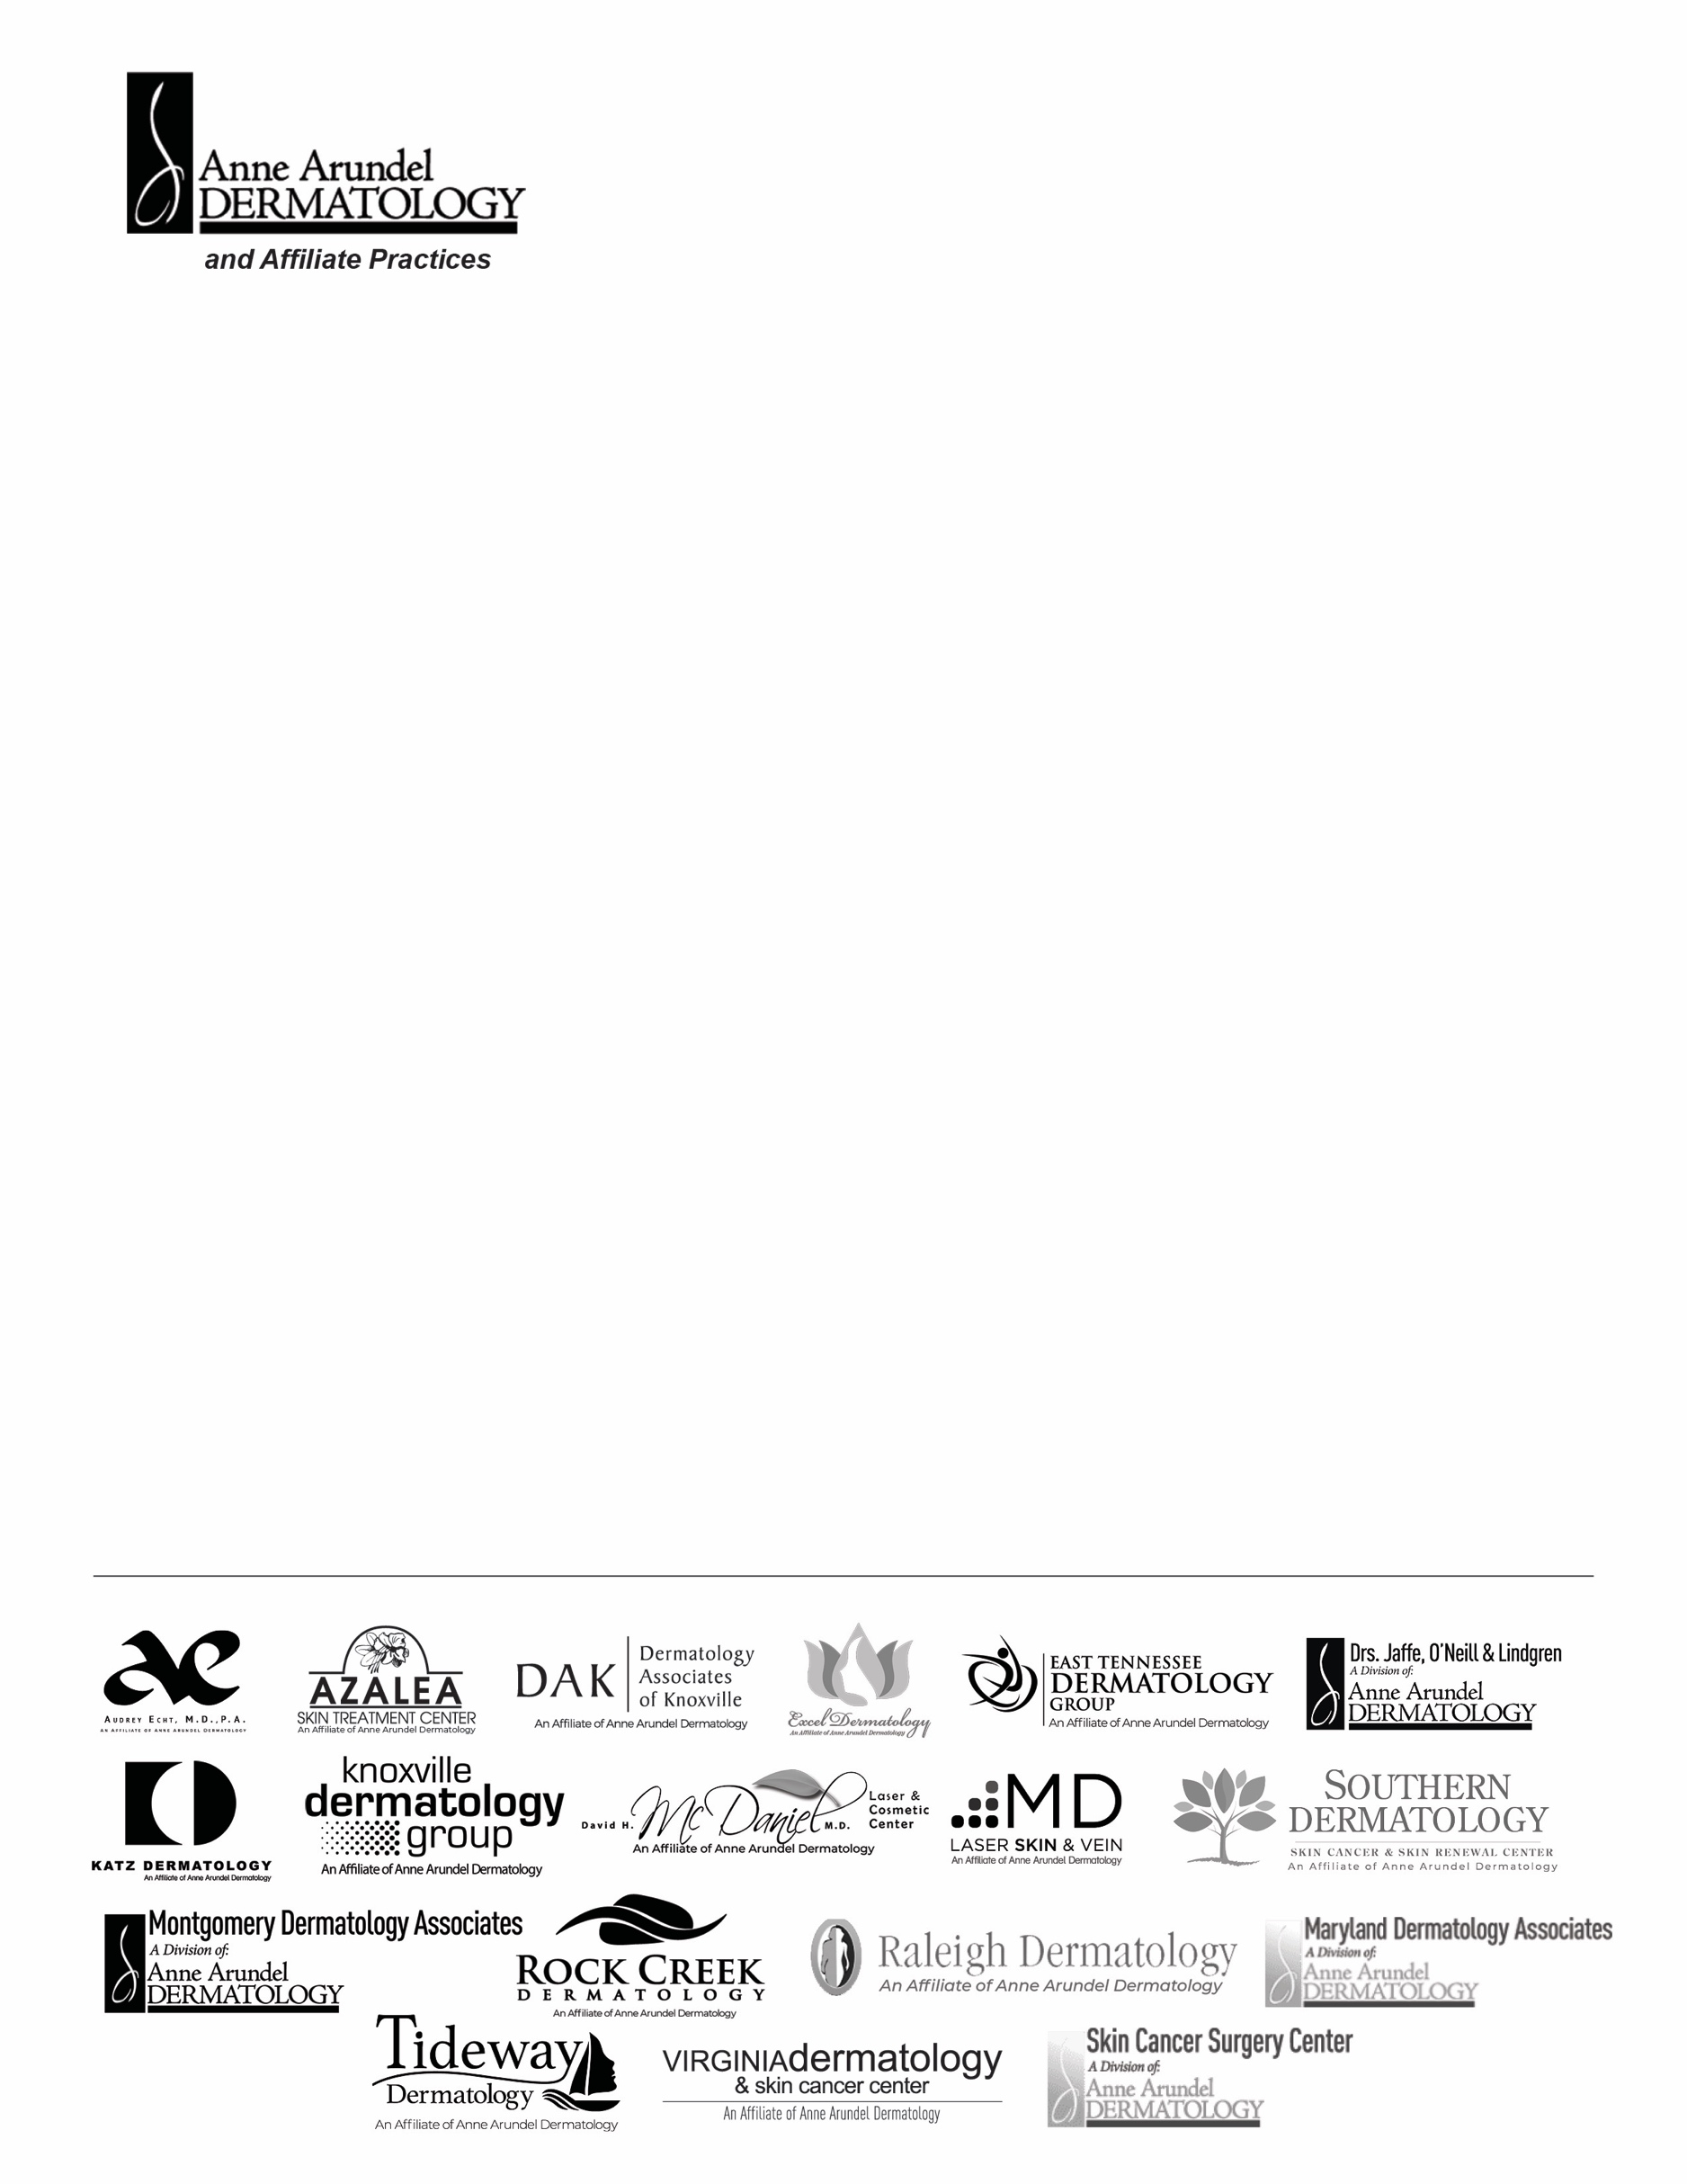

_______________________, 2020

COVID-19 Essential Employee Travel Authorization Letter

The bearer of this letter is an employee, EMPLOYEE NAME, who is responsible for a critical function as a JOB TITLE at Anne Arundel Dermatology, P.A., or any of its affiliates, that operate in multiple states inclusive of Maryland, Virginia, Tennessee, and North Carolina.
Anne Arundel Dermatology, P.A., or any of its affiliates, is a dermatology practice and we appreciate your support in allowing our employee to continue to travel to complete HER/HIS duties in the physical office as we continue to provide urgent essential health care for patients in the community.
Signed by:
Jaime Strickland
Vice President of Human Resources

If you have questions about this employee’s affiliation with Anne Arundel Dermatology, P.A. please contact Human Resources at (410)384-9311 option 2 or hr@aadermatology.com or PRACTICE MANAGER NAME at PHONE NUMBER.

